|  |
| --- |
| College LaSalle |
| Project - Internet Programming Technical Manual |
|  |
| Presented to: Mihai Maftei |

|  |
| --- |
| Author: Samuel Fauteux  4/18/2021 |

Start by adding a short description of your project, and the languages (technologies) used

Languages:

1. XHTML 1.0
2. HTML5
3. CSS3
4. Java Script 3.4.1minimum

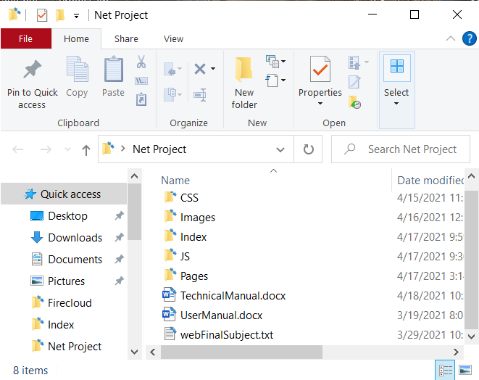Presenting how the files/folders are organised.

1. CSS
   1. IndexStyle.css (contains the style

for the index page, was used for

the frames when I was using

frames)

* 1. Style.css (contains the

background since it is the same

for all pages, all pages loads this

css)

* 1. textPages.css (contains the shared style of Opening.html and Info.html)

1. Images
   1. InfoPictures (all pictures in this directory are the one used on Info.html)
   2. Unused (this directory contains all the pictures I downloaded/made for the site that in the end were not directly used by this project)
   3. UserManuel (this directory contains all the screenshots for the user manual)
   4. Background.jpg (the background image for all my pages)
   5. H._P._Lovecraft,_June_1934.jpg (the picture of HP. Lovecraft used in Opening.html)
   6. LogoTransparentBG2.PNG (the wind spreader’s community logo)
   7. lovecraft-country-map.jpg (the map user on Lovecraft Country Map.html)
   8. Net Project Tree.PNG (the picture in the corner of this section)
2. Index (this folder contains all the indexes and frames of when I was still using a frameset, only Content.htm is still used in it)
   1. Content.html (the default content of the content frame/iframe, depending on which index.html launched)
   2. index.html (the launch page of when I was using a frameset)
   3. indexTableMess.html (I tried fixing my iframe alignment problem with a table but this only made things messier)
   4. Menu.htm (the frame version of my Menu div)
   5. Top.htm (the frame version of my Top div)
3. JS
   1. jquery-3.4.1.min.js (the used version of jquery)
   2. LoginAndRegistration.js (this contains the function used by index.html and Register.htm)
   3. Subscription.js (this validates the content of the subscription form and creates the related cookies)
4. Pages
   1. Bibliography.html (where credit is given)
   2. Index.html (the home page of this site)
   3. Info.html (info on the presented towns, this is also where the map sends you)
   4. Lovecraft Country Map.html (the map)
   5. Opening.html (The opening page where I present a bit Lovecraft)
   6. Register.htm (the registration page)
   7. Subscription.html (the subscription form)
   8. Verify form information.html (that page where you can verify the latest info sent with the form and how long it took you to complete this form)
5. TechnicalManual.docx (this document)
6. UserManual.docx (description of the pages functionalities with screen shots)
7. webFinalSubject.txt (the document I sent when we were asked to deliver our subject)

Present the functions and/or methods that you create or you did use into the web project.

|  |  |
| --- | --- |
| **Function/Method** | **Description** |
| 1. OpenRegistrationPage() | Tells you that you failed too login and change the iframe content to Registration.htm |
| 1. alert() | Makes a popup warning in the middle of your screen |
| 1. document.getElementsByName() | Returns an array of all html elements with matching names |
| 1. getCookie() | The solution Mr. Maftei sent us to catch the desired cookie |
| 1. document.cookie.split() | Returns an array of substrings delimited by the chosen char |
| 1. .indexOf() | Returns the start index of the chosen element in an array |
| 1. .substring() | Returns the substring between 2indexes |
| 1. .length | Returns the number of elements in an array |
| 1. .CharAt() | Returns the character at the specified index |
| 1. document.getElementById() | Returns the html element with the chosen id |
| 1. .value | Returns the value of an element |
| 1. Login() | Show the menu if the credentials are right, if they are not, change the iframe content for Register.htm |
| 1. .show() | Shows the selected content |
| 1. Register() | Lets the user register |
| 1. .setTime() | Set the time of a Date() |
| 1. .getTime() | Get the time of a Date() |
| 1. document.cookie | Can be used to access or create cookies |
| 1. HideTheMenu() | Hides the Menulinks |
| 1. .ready() | Activates when the element is ready |
| 1. .hide() | Hides the selected element |
| 1. ValidateProperName() | Checks if the value of the sent element is a proper name, if not, it warns the user with an alert() |
| 1. ValidateEMailAddress() | Checks if the value of the sent element is an eMail address , if not, it warns the user with an alert() |
| 1. ValidatePhoneNumber() | Checks if the value of the sent element is a phone number, if not, it warns the user with an alert() |
| 1. ValidateBDate() | Calculates the age of the user based on its birth date, if the user seems a bit too young, it warns him with an alert() |
| 1. .test() | Check if the selected value match a Regexp |
| 1. .style.border | Sets a border style |
| 1. SetStartTime() | Sets this variable |
| 1. VerifyEntry() | Checks that you correctly filled the form and warns the user if they have been subscribed or not, in the case that it has been subscribed, it creates the right cookies |
| 1. .toUTCString() | Returns a Date() UTC value |
| 1. window.onscroll | Activates when the page is scrolled |
| 1. MakeStickyOrNot() | Toggle the sticky class |
| 1. .offsetTop | Get the YOffset of the top of the page |
| 1. pageYOffset | Get how much the user did scroll |
| 1. classList.add | Adds a class to an element |
| 1. classList.remove | Removes a class to an element |
| 1. GoToSearch() | Sends the user to the element they searched if it is in this page |
| 1. .toLowerCase | Returns the same string but in lowercase |
| 1. .toUpperCase | Returns the same string but in uppercase |
| 1. .scrollIntoView() | Srolls in a way that makes the selected element visible in the page |
| 1. FillForm() | Filla this page with the form informations |
| 1. .innerHTML | Allows to set something in an element |